Mitchell Duran
08/20/2026

Pseudocode

BEGIN
SET firstName = "Avery"
SET lastName = "Everhart"
SET streetAddress = "123 Lake Street"
SET city = "Olympia"
SET zipCode = "06070"

PRINT firstName
PRINT lastName
PRINT streetAddress
PRINT city
PRINT zipCode
END

package csc320;

public class PersonInfo {

public static void main(String[] args) {
String firstName = "Avery";
String lastName = "Everhart";
String streetAddress = "123 Lake Street";
String city = "Olympia";
String zipCode = "06070";

System.out.println(firstName);
System.out.println(lastName);
System.out.println(streetAddress);
System.out.println(city);
System.out.println(zipCode);
}

}

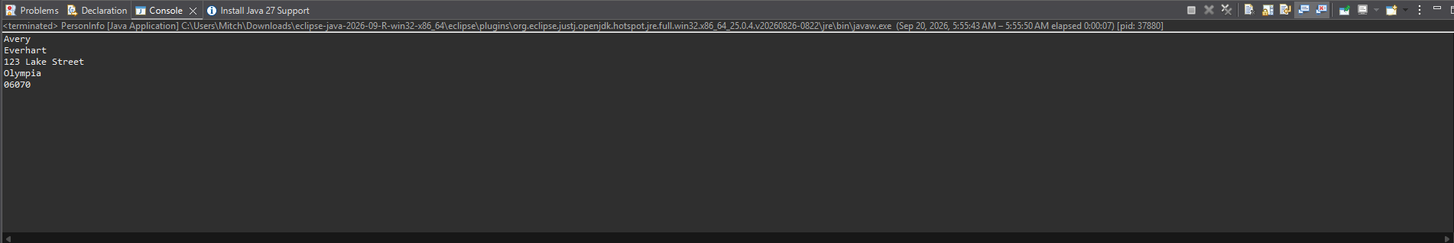
https://github.com/Mitch-CA/CSC320.git

